1. Create an array of 10 elements and print them using the for each loop.

*LIJIN JOY - 211441*

package com.student.beans;

public class ArrayExample {

public static void main(String[] args) {

int arr[]= {10,20,30,40,50,60,70,80,90,100};

System.out.println("The array elements are printed using for each loop");

for(int var:arr)

{

System.out.println(var);

}

}

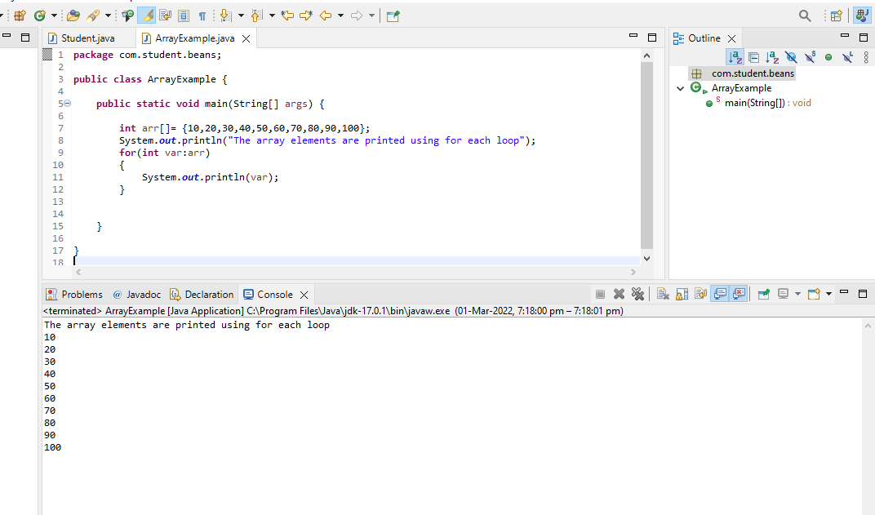

2. Take the number input from the console and add all the positive numbers. (not to consider the negative number if entered)

import java.util.Scanner;

public class SumOfNumbers {

public static void main(String[] args) {

System.out.println("Enter the Number of elements :");

Scanner sc =new Scanner(System.in);

int num;

num=sc.nextInt();

int[] a= new int[num];

System.out.println("Enter the elements :");

for (int i = 0; i < num; i++)

{

a[i]=sc.nextInt();

}

int sum=0;

for (int i = 0; i < num; i++)

{

if(a[i] >=0)

sum=sum+a[i];

}

System.out.println("The sum of positive numbers are " +sum);

}

}

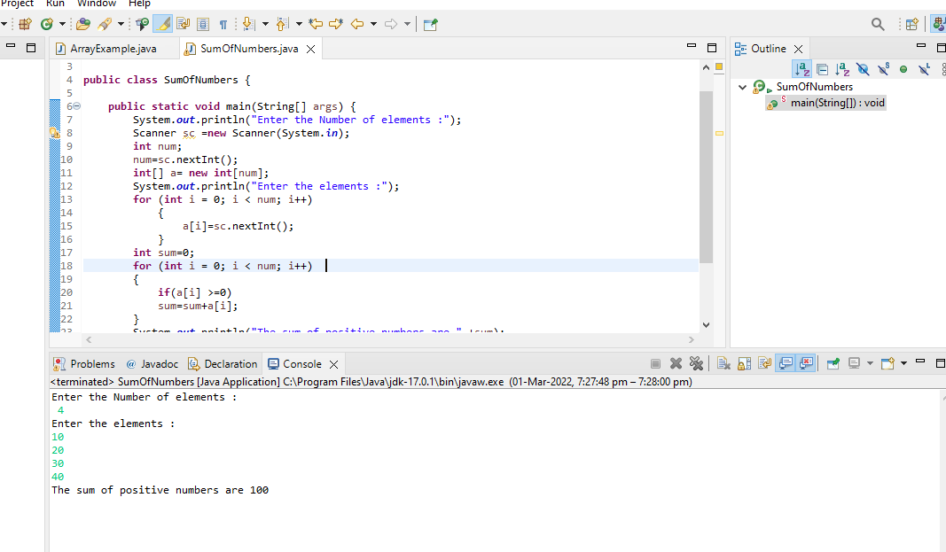

3. Create a labeled break and write a simple logic and execute the program.

**public** **class** Question3 {

**public** **static** **void** main(String[] args) {

outerforloop:

**for**(**int** i=1;i<=3;i++)

{

innerforloop:

**for**(**int** j=1;j<=3;j++)

{

**if**(i==2&&j==2)

{

**break** outerforloop;

}

System.***out***.println(i+ " , " +j);

}

}

}

}

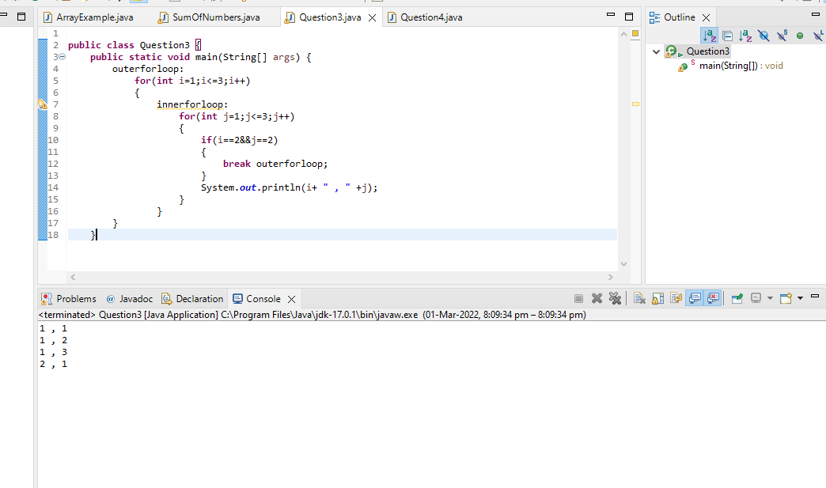

4. Do the addition of around 10 even numbers, but use the continue statement in the logic.

**public** **class** Question4 {

**public** **static** **void** main(String[] args) {

**int** count=0;

**int** sum=0;

loop1:

**for**(**int** i=1;i<50;i++)

{

**if**(i%2!=0)

{

**continue**;

}

**else** **if**(i%2==0)

{

sum+=i;

count++;

**if**(count==10)

{

**break** loop1;

}

}

}

System.***out***.println("The sum of 10 even numbers is " +sum);

}

}

